**INDIAN AGRICULTURAL CROP PRODUCT ANALYSIS(1997-2021)**

1. **Introduction:**
   1. **Overview:**

Agriculture is the backbone of Indian from the ancient time till the date. There has a big history for Indian agricultural crop products. In India 95% of peoples are still depends on the agricultural products. From small pity jobs there are much jobs deals with the crop products in world-wide. Making jute bags, handcrafted gifts to the degrading plates we are depending on agriculturals products.

* 1. **Purpose:**

This project is all about knowing the crop production in India. By this project we can understand the gain and loss in the production from 1997-2021. This project also helps to known the advantages and disadvantages that took place by the chemicals in the agricultural land we can also compare the production of the crop products according to the seasons, area and the land.

1. **Problems Definition and Design thinking:**
   1. **Empathy map:**

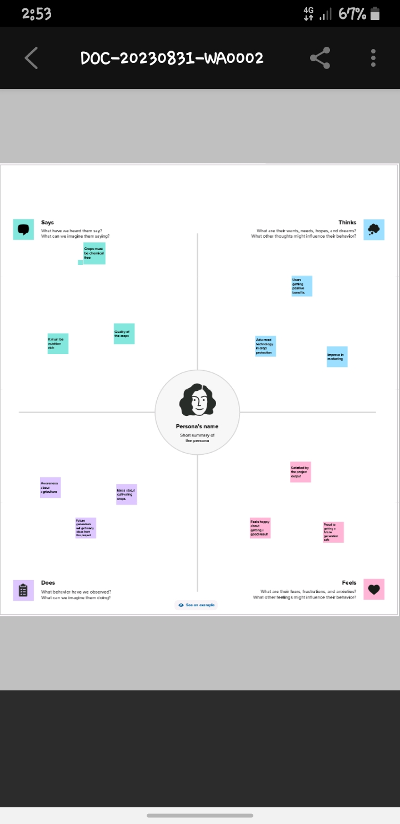

* 1. **Brainstorming map:**

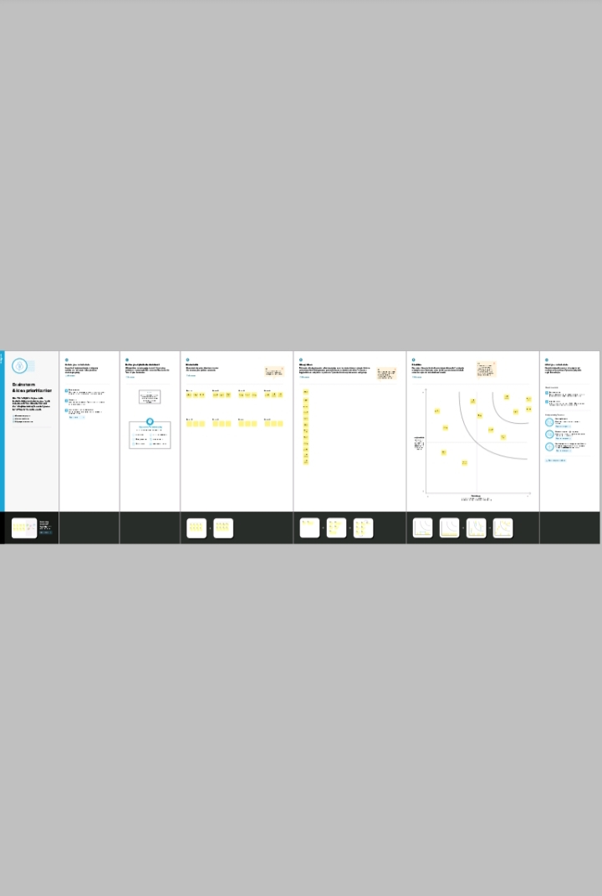

1. **Result:**

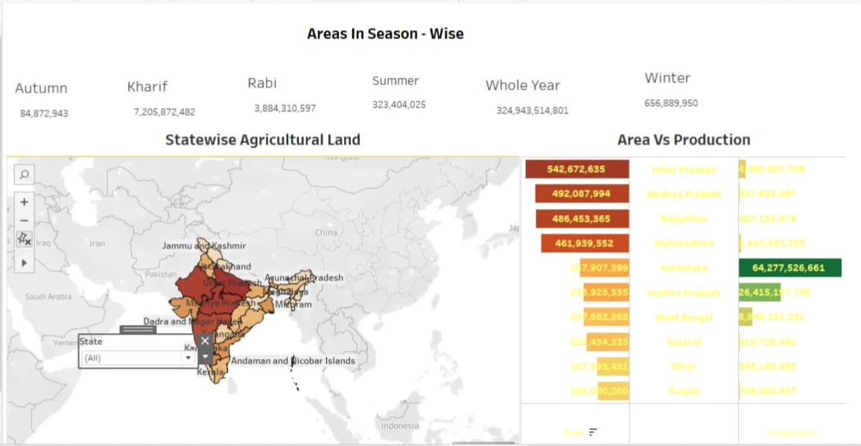

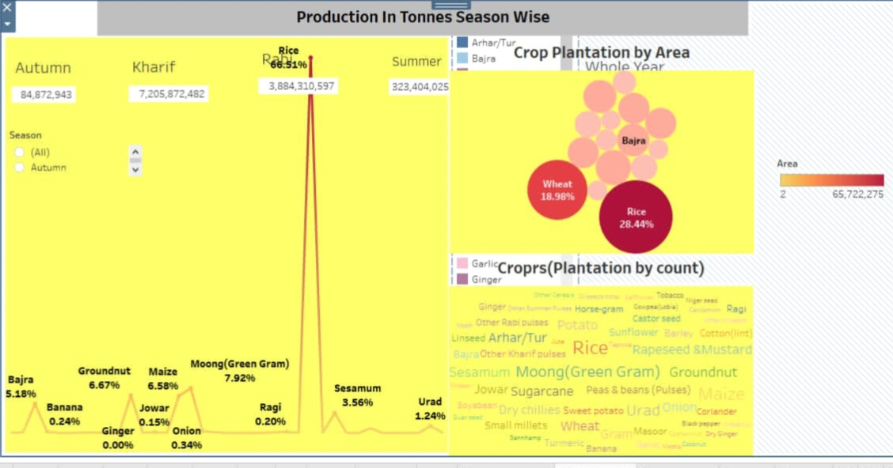

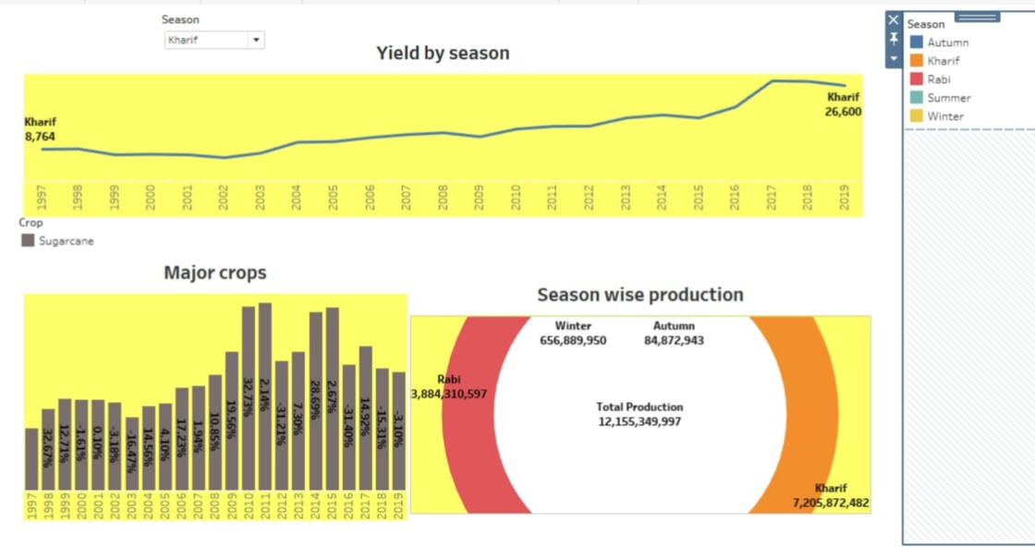

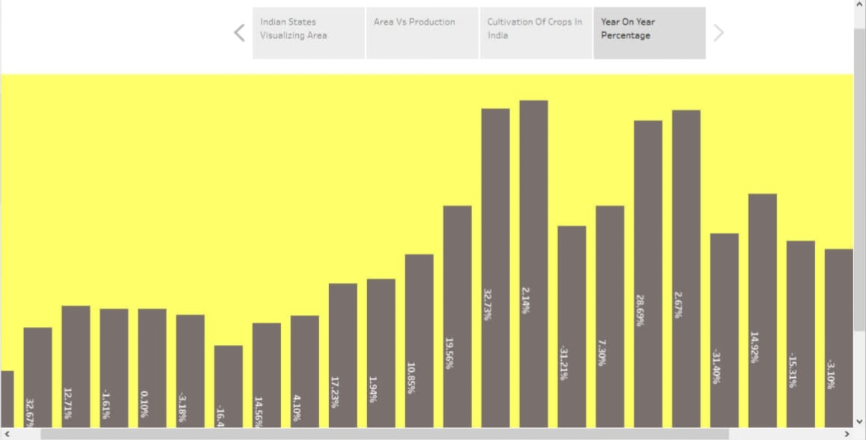

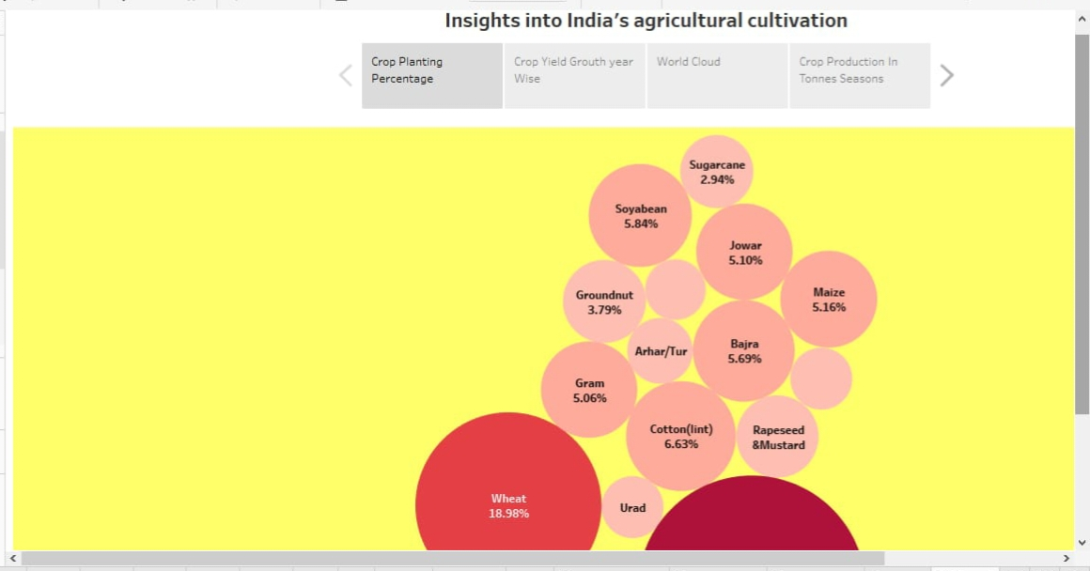

1. **Advantages and Disadvantages:**

**Advantages:**

Agriculture analysis is a very important aspect to crop growing. To increase quality and yields, it is crucial to understand the current nutrient levels of the soil to be able to ascertain which areas require improvement. In kharif season the production level is very high.

**Disadvantages:**

* When compare to the summer season other seasons the production is low.
* The production of rice crop plantation by area is very high other products is not much.

1. **Applications:**

Farmers can observe the impact that extreme weather conditions and other phenomena can have on their crops. We can apply in benchmarking, sensor deployment, analytics and predictive modelling. This project can help the farmers as well as insurers.

1. **Conclusions:**

The agricultural sector is of vital importance for the region. It is undergoing a process of transition to a market economy with substantial changes in the social, legal structural, productive and supply set-ups as is the case with all other sectors of the economy.

1. **Future Scope:**

We can improve our project by adding other countries crop production details to dataset and by adding the fertilizers details of every farmers used for their crops.